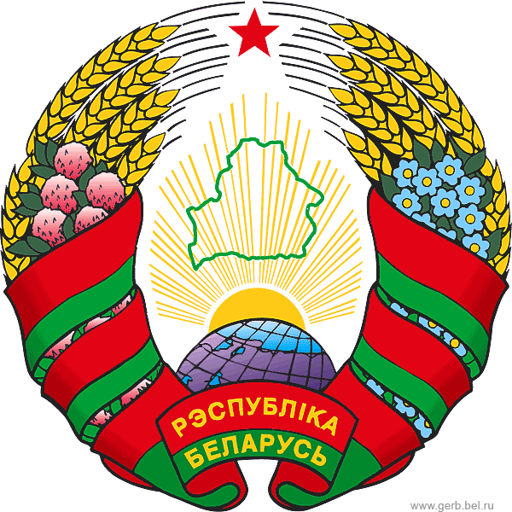

UNRRA and UNDP in Belarus:
History, Traditions and Continuity
special THEMATIC briefing
UN Headquarters, New York, April 13, 2016

Background and objectives
In 1945 the United Nations Relief and Rehabilitation Administration (UNRRA) was founded. Its mission was to provide economic assistance to European nations after World War II. The United States was the leading donor of the agency.
UNRRA was present in 44 nations, including Belarus. The UNRRA Mission to Belarus was established in Minsk on April 16, 1946 and this year marks the 70th anniversary since began its work in Belarus.
UNRRA significantly contributed to the post-war reconstruction and development through provision of food, fuel, clothing, shelter, medical and other essential services to the countries devastated by WWII. UNRRA is rightly considered as the first ever humanitarian mission in the United Nations that gave an important initial impetus for the creation of an elaborate United Nations system of development assistance.
As UNRRA shut down its operations in 1947, its functions were transferred to other UN agencies. The United Nations Development Programme that was founded twenty years later and this year celebrates the 50th anniversary of its admirable development and humanitarian achievement can be seen as a direct descendant of UNRRA as the first UN assistance and development agency.
Belarus was the first country of the former Soviet Union to open a UNDP office and since 1992 has been steadily developing its cooperation with UNDP.
As the international community begins its important work of implementing the 2030 Agenda for Sustainable Development, it is important to be more fully aware of the history of international development assistance in order to build on the strengths of its best examples.
A special briefing “Belarus-UNRRA-UNDP: History and Development” seeks to raise awareness of accomplishments of the United Nations over 70 years through the multilateral development activities in Belarus – the accomplishments made possible by the benevolence, responsibility and commitment of the donor community.

Organiser: Permanent Mission of Belarus to the UN
Time & venue: Wednesday, April 13, 2016, 10 am – 11.30 pm,
Conference Room 8 (Conference Building)
Participation: All are invited

programme
- Statements by the invited speakers (moderated by the Permanent Mission of Belarus):
- Valentin Rybakov, Deputy Minister of Foreign Affairs of the Republic of Belarus
- Cihan Sultanoglu, UNDP Assistant Administrator and Regional Director of the UNDP Europe and Commonwealth of Independent States
- Esther Pan Sloane, US Mission, Adviser to ECOSOC
- Stephen Haufek, Chief of Archives, United Nations Archives and Records Management Section
- Q&A

For inquiries about the event please contact Mrs Irina Velichko, Minister Counsellor, Mission of Belarus
e-mail: iravelichko@gmail.com, phone (917) 664-3776

